**SSN COLLEGE OF ENGINEERING, KALAVAKKAM  
DEPARTMENT OF COMPUTER SCIENCE AND ENGINEERING  
UCS1712 – GRAPHICS AND MULTIMEDIA LAB ------------------------------------------------------------------------------------------------------------**

**Lab Exercise 6: 2D Composite Transformations and Windowing in C++ using OpenGL**

**Aim:**

**a) To compute the composite transformation matrix for any 2 transformations given as input by the user and apply it on the object.**

The transformation can be any combination of the following.

1. Translation
2. Rotation
3. Scaling
4. Reflection
5. Shearing

Display the original and the transformed object.

**Source Code:**

#include<GLUT/glut.h>

#include<iostream>

#include<cmath>

#include<string>

#include<iomanip>

#include<sstream>

using namespace std;

const double PI = 3.14159265;

void drawString(float x, float y, const char *string){

glRasterPos2f(x, y);

for(const char* c = string;*c!='\0';c++)

glutBitmapCharacter(GLUT_BITMAP_HELVETICA_12, *c);

}

void myInit() {

glClearColor(1.0,0.6,0.5,0.0);

glPointSize(1);

glMatrixMode(GL_PROJECTION);

glLoadIdentity();

gluOrtho2D(-320.0,320.0,-240.0,240.0);

}

void pltFig(float arr[][3],int n){

glBegin(GL_POLYGON);

for(int i=0;i<n;i++){

glVertex2f(arr[i][0],arr[i][1]);

}

glEnd();

}

void plotPoints(float arr[][3],int n){

for(int i=0;i<n;i++){

stringstream s,s2;

s<<arr[i][0];

s2<<arr[i][1];

drawString(arr[i][0], arr[i][1], ("("+s.str()+","+s2.str()+")").c_str());

}

}

void matMul(float a[][3], float b[][3],float mult[][3],int n){

for(int i = 0; i < n; ++i)

for(int j = 0; j < 3; ++j)

for(int k = 0; k < 3; ++k)

{

mult[i][j] += a[i][k] * b[k][j];

}

}

void matCopy(float a[][3],float mult[][3],int n){

for (int i = 0; i < n; i++) {

for (int j = 0; j < 3; j++) {

a[i][j] = mult[i][j];

}

}

}

void translation(float arr[][3],int n, float tx, float ty,float mul[][3]){

float b[3][3]={{1,0,0},{0,1,0},{tx,ty,1}};

matMul(arr, b, mul, n);

}

void rotation(float arr[][3],int n, int a,float mul[][3],int xr=0,int yr=0){

double angle = a * PI / 180.0;

float b[3][3]= {{float(cos(angle)),float(sin(angle)),0},{float(-1*sin(angle)),float(cos(angle)),0},{xr*(1-float(cos(angle)))+yr*float(sin(angle)),yr*(1-float(cos(angle)))-xr*float(sin(angle)),1}};

matMul(arr, b, mul, n);

}

void scaling(float arr[][3],int n, float sx, float sy,float mul[][3],int xf=0,int yf=0){

float b[3][3]= {{sx,0,0},{0,sy,0},{xf*(1-sx),yf*(1-sy),1}};

matMul(arr, b, mul, n);

}

void reflection(float arr[][3],int n, float mul[][3],int choice){

if(choice==1){

float b[3][3]={{1,0,0},{0,-1,0},{0,0,1}};

matMul(arr, b, mul, n);

}

else if(choice==2){

float b[3][3]={{-1,0,0},{0,1,0},{0,0,1}};

matMul(arr, b, mul, n);

}

else if(choice==3){

float b[3][3]={{-1,0,0},{0,-1,0},{0,0,1}};

matMul(arr, b, mul, n);

}

else if(choice==4){

float b[3][3]={{0,1,0},{1,0,0},{0,0,1}};

matMul(arr, b, mul, n);

}

}

void shearing(float arr[][3],int n, float s,float mul[][3],int choice){

if(choice==1){

float b[3][3]={{1,0,0},{s,1,0},{0,0,1}};

matMul(arr, b, mul, n);

}

else{

float b[3][3]={{1,s,0},{0,1,0},{0,0,1}};

matMul(arr, b, mul, n);

}

}

void myDisplay(){

glClear(GL_COLOR_BUFFER_BIT);

glColor3f(0.0,0.0,0.0);

/* To plot axes */

glBegin(GL_LINES);

glVertex2f(-320.0,0.0);

glVertex2f(320.0,0.0);

glVertex2f(0.0,-240.0);

glVertex2f(0.0,240.0);

glEnd();

int n,ch;

char choice;

float arr[10][3];

cout<<"Enter number of vertices: ";

cin>>n;

cout<<"Enter vertices (x,y): "<<endl;

for(int i=0;i<n;i++){

cin>>arr[i][0]>>arr[i][1];

arr[i][2]=1;

}

cout<<"MENU\n1.Translation\n2.Rotation\n3.Scaling\n4.Reflection\n5.Shearing\n";

pltFig(arr, n);

plotPoints(arr,n);

do{

cout<<"Enter choice of transformation: ";

cin>>ch;

float mul[10][3]={0};

switch(ch){

case 1:

{

float tx,ty;

cout<<"Enter translation values: ";

cin>>tx>>ty;

translation(arr,n,tx,ty,mul);

glColor3f(1.0,1.0,1.0);

matCopy(arr,mul,n);

break;

}

case 2:

{

int angle,c,xr,yr;

cout<<"Enter rotation degree: ";

cin>>angle;

cout<<"1. about origin\n2. about fixed point\nChoice = ";

cin>>c;

if(c==1) rotation(arr,n,angle,mul);

else{

cout<<"Enter fixed point: ";

cin>>xr>>yr;

rotation(arr, n, angle, mul,xr,yr);

}

glColor3f(1.0,1.0,1.0);

matCopy(arr,mul,n);

break;

}

case 3:

{

float sx,sy;

int c,xr,yr;

cout<<"Enter Scaling values: ";

cin>>sx>>sy;

cout<<"1. about origin\n2. about fixed point\nChoice = ";

cin>>c;

if(c==1) scaling(arr,n,sx,sy,mul);

else{

cout<<"Enter fixed point: ";

cin>>xr>>yr;

scaling(arr,n,sx,sy,mul,xr,yr);

}

glColor3f(1.0,1.0,1.0);

matCopy(arr,mul,n);

break;

}

case 4:

{

int c;

cout<<"1. x-axis\n2. y-axis\n3. origin\n4. the line x=y\nChoice = ";

cin>>c;

reflection(arr,n,mul,c);

glColor3f(1.0,1.0,1.0);

matCopy(arr,mul,n);

break;

}

case 5:

{

float s;

int c;

cout<<"1. x-direction shear\n2. y-direction shear\nChoice = ";

cin>>c;

cout<<"Enter shear value: ";

cin>>s;

shearing(arr,n,s,mul,c);

glColor3f(1.0,1.0,1.0);

matCopy(arr,mul,n);

break;

}

default:

cout<<"Invalid Option"<<endl;

}

cout<<"Apply more transformation? (y/n) : ";

cin>>choice;

}while(choice=='y');

pltFig(arr, n);

plotPoints(arr, n);

glFlush();

}

int main(int argc,char* argv[]) {

glutInit(&argc,argv);

glutInitDisplayMode(GLUT_SINGLE|GLUT_RGB);

glutInitWindowSize(480,480);

glutCreateWindow("2D Composite Transformations");

glutDisplayFunc(myDisplay);

myInit();

glutMainLoop();

return 1;

}

**Output:**

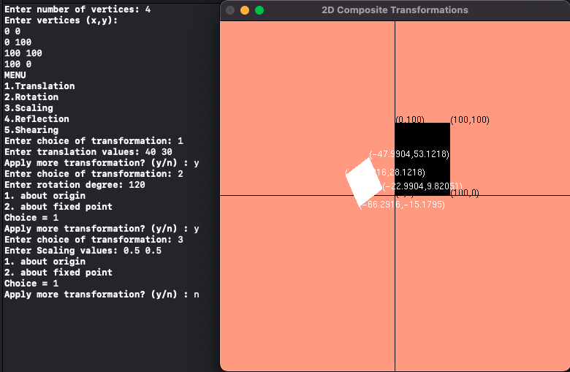

**b) Create a window with any 2D object and a different sized viewport. Apply window to viewport transformation on the object. Display both window and viewport.**

**Learning Outcomes:**